BSc in Web Technologies & Programming

Cross Platform Mobile Application Development

Recipes

G00012318

James Taylor

Contents

[Introduction 3](#_Toc448233689)

[Device Functionality 3](#_Toc448233690)

[Usage 3](#_Toc448233691)

# Introduction

This application is a Recipes guide Application. It allows the user to add items with pictures to the lunch tab. The Dessert tab can be edited and this will be stored persistently. You can choose to edit the picture by taking a new pic or by selecting an exesting pic from the phones photo album. The Name and Desc fields can be edited also. A Grams/Oz convertor and a barcode reader are also included in the side menu.

There are 3 screens on the app:

Lunch tab shows one item

Dinner tab shows three items, each clickable to enter its detail page for Ingredients

Dessert tab has one item, Two option buttons underneath when you slide left.

A side menu when you slide right from either the Lunch,Dinner or Dessert tabs.

# Device Functionality

links to device functionality provided by ngCordova are included below;

Camera - <http://ngcordova.com/docs/plugins/camera/>

Barcode scanner - <http://ngcordova.com/docs/plugins/barcodeScanner/>

To get access to the phones photo album the source type is changed to

sourceType: Camera.PictureSourceType.SAVEDPHOTOALBUM

# Usage:

# On the home page you will see the lunch tab. When you slide the screen to the right you will see the side menu, This can be accessed on any screen bar the Dinner tabs detail pages.

# C:\Users\Jimmy\AppData\Local\Microsoft\Windows\Temporary Internet Files\Content.Word\Screenshot_2016-04-29-14-38-05.png C:\Users\Jimmy\AppData\Local\Microsoft\Windows\Temporary Internet Files\Content.Word\Screenshot_2016-04-29-14-38-55.png

The “Get Barcode” button will open the camera and use it to read a bar code. The “Add lunch item” button will add a new div tag in the list to add a new lunch item. See below. This data is not stored and so will be lost when the app is closed.

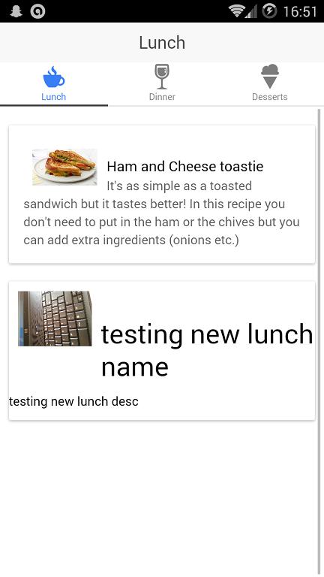

# Next you have the Dinner tab and when you click into for ex the Salmon item you can see its Ingredients page.

# C:\Users\Jimmy\AppData\Local\Microsoft\Windows\Temporary Internet Files\Content.Word\Screenshot_2016-04-29-14-38-15.png dinnerDetail.gif

# Finally you have the Dessert tab and once you slid the item bar left you reveal its two options to edit the pic and the Name/Desc fields

# C:\Users\Jimmy\AppData\Local\Microsoft\Windows\Temporary Internet Files\Content.Word\Screenshot_2016-04-29-14-40-19.png C:\Users\Jimmy\AppData\Local\Microsoft\Windows\Temporary Internet Files\Content.Word\Screenshot_2016-04-29-14-40-27.png

# When you edit the dessert item it is stored in local storage. When you exit the app the new info will still be present when you enter the app again.

# new Desc.png